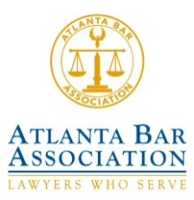  2022 Most Innovative Corporate IP Law Department Award Nomination Form | 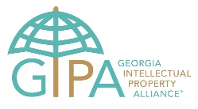

Please submit your nomination for the 2022 Most Innovative Corporate IP Law Department Award via email to: cbroussard@atlantabar.org.
The winning law departments will be honored at the 18th Annual SpringPosium Intellectual Property Conference, details to follow.

* Required

Your Information
Name* |  | Phone Number*
Job title* |  | Phone Number*
Your Company/Firm Name* |  | E-mail Address*

Nominee Details
Company Name* |  | Company Industry*
Contact Name* |  | Company Size/Type*  (e.g., non-profit, public, private, university)
Job Title*
E-mail Address* |  | Company Address*
Phone Number*

In about 500 words or less, tell us why your nominee company has the most innovative IP law department. (This is your chance to make them shine!) *

Please paste any web links to supporting documents here (or otherwise attach to email submission).

